This document contains traces and descriptions of tests against a real 68B00 the tests are to flush out the bahviour of the HALT pin not covered in the datasheets.

NOTE: nHALT is latched by cpu at end of phi1 (subject to tPCS)
NOTE: nRES is lattched by cpu at end of phi2 (subject to tPCS)

HALT active during reset

Vector is fetched then bus released, first instruction executed cycle after halt release

HALT occurs during first cycle of VECTOR FETCH after RESET

The vector is fetched, first instruction held until nHALT released

HALT occurs during second cycle of VECTOR FETCH after RESET

Vector fetched, first instruction is halted

HALT occurs during fetch of first instruction

First instruction executed, next halted

HALT occurs during 1st operand of 3 byte instruction

Next instruction is halted

HALT occurs during 2nd operand of 3 byte instruction

Next instruction is still halted

Halt blips low during 1st vector fetch
Is ignored

Halt blips low during 2nd vector fetch
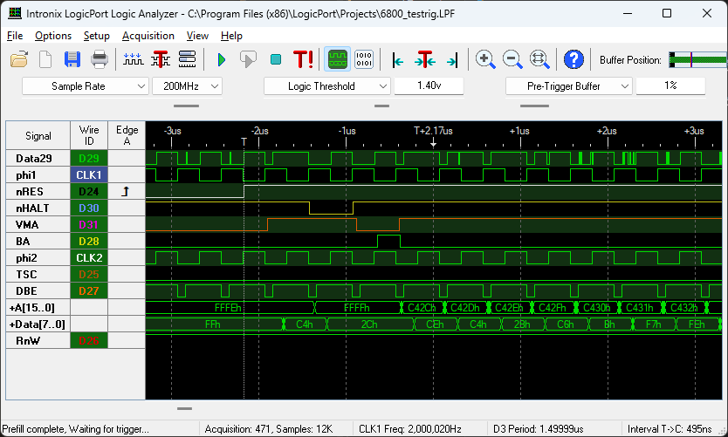
Cycle after 2nd vector fetch is skipped NOTE – BA only asserted for half cycle

Halt blips low during 1st fetch
Ignored

Halt blips low during oper 1 of 16 bit immed
Ignored

Halt blips low during oper 2 of 16 bit immed

Next instruction pauses, ½ cycle BA

Halt blips low during fetch
Ignored

Halt blips high during 1st vector

Ignored, vector fetched then halt.
Following blip high shows a normal “single-step”

Halt blips high during 2nd vector

Following instruction is executed immediately

Halt blips high during cycle after 2nd vector fetch

As expected for first instruction, as expected 2nd instruction is delayed 1 cycle when previous LIC cycle is nHALT

Conclusions
HALT is registered and acted on during the cycle BEFORE a fetchin the
CORE needs a LIC signal to allow BA to go high during a halt after phi1 – or should it just be BA combines in CORE?
In use with real CPU BA should be registered in middle of phi1 like A, RnW etc and otherwise ignored

